SCREENSHOTS OF THE PROJECTS
1. Here is the terminal of VSCode showing properly execution of POSTMAN
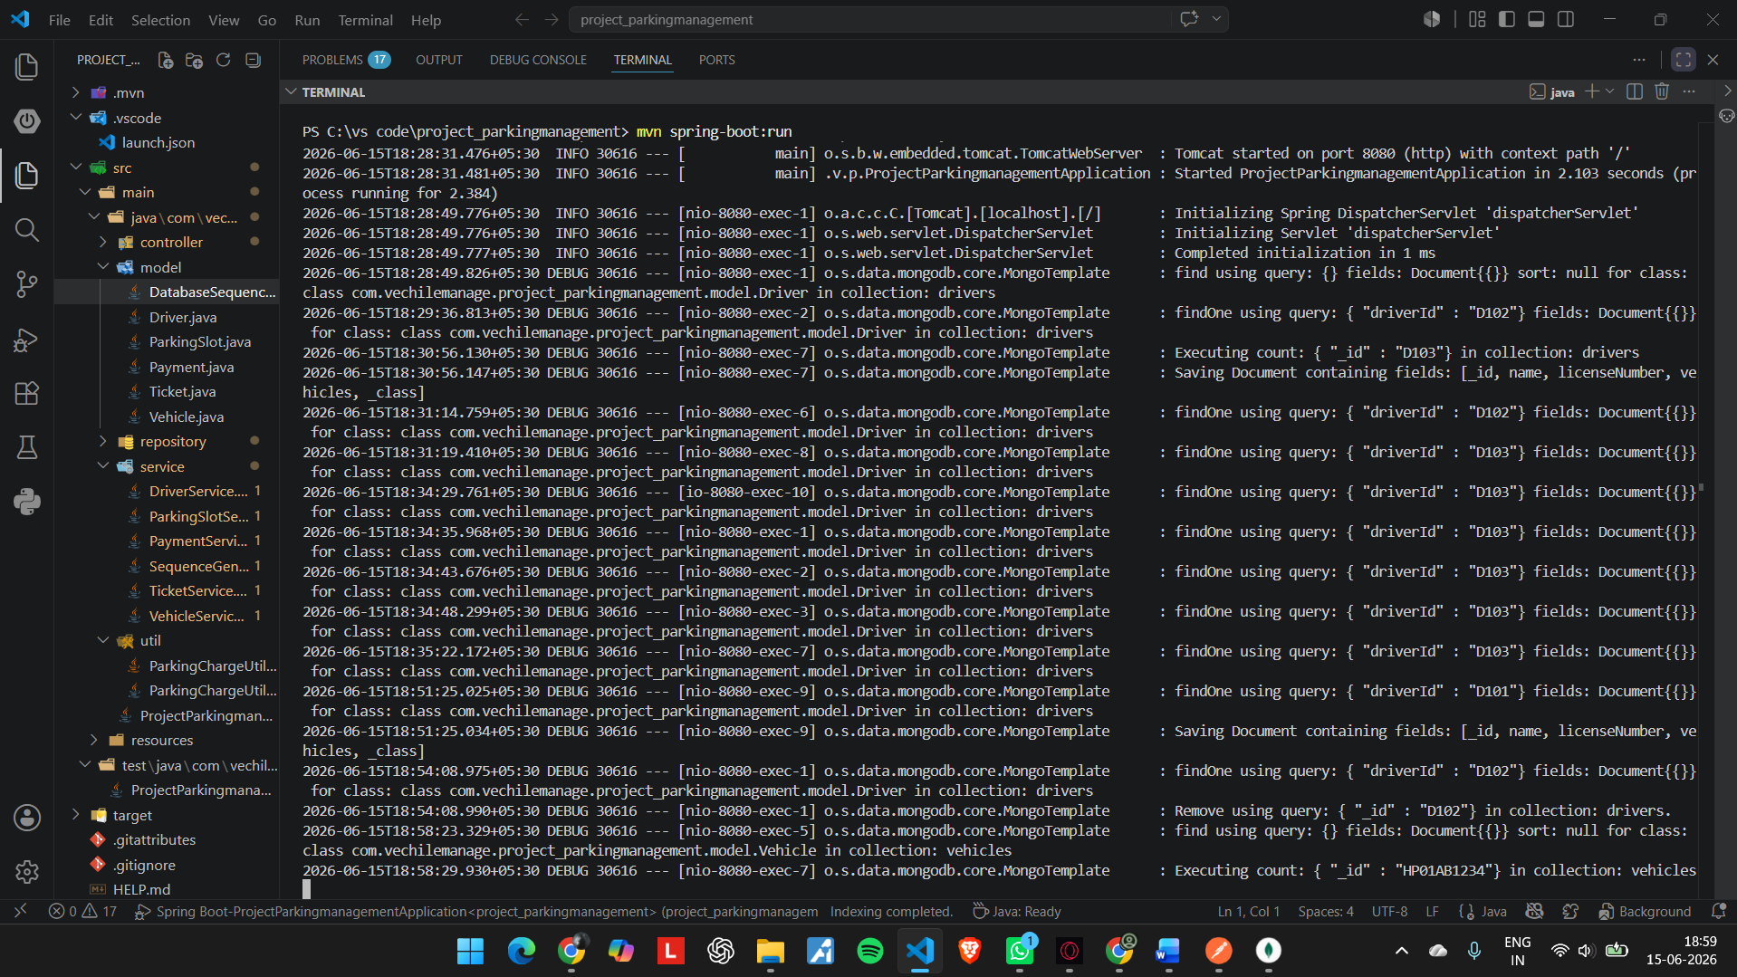
Terminal showing – changes appeared on the Terminal
--------------------------------------------------------------------------------------------------------------------------
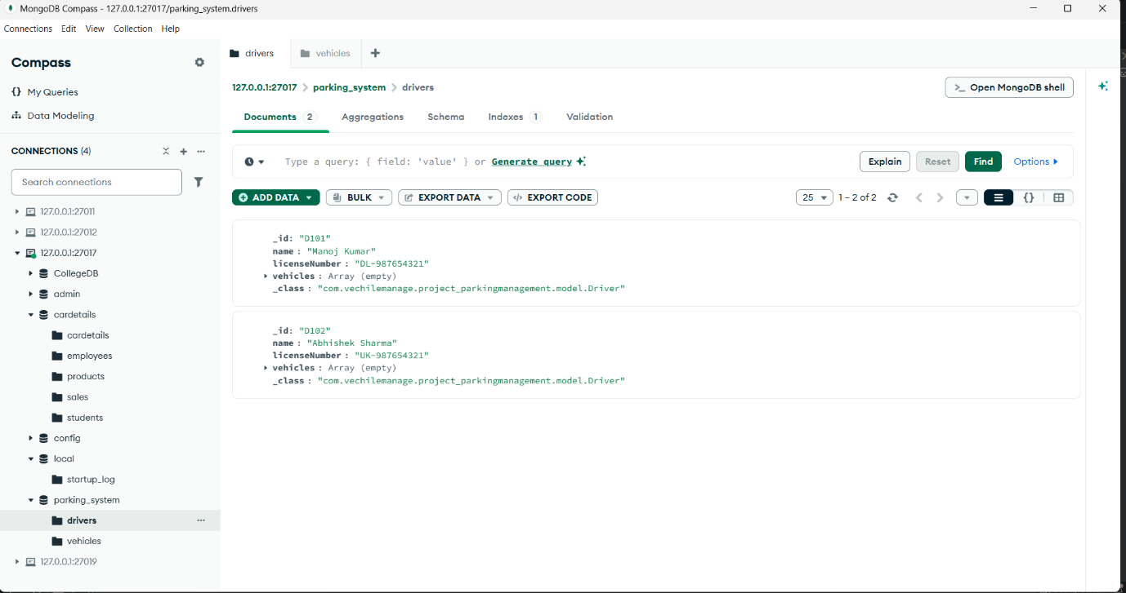
MongoDB_Database_for_Driver( MongoDB Compass)
--------------------------------------------------------------------------------------------------------------------------

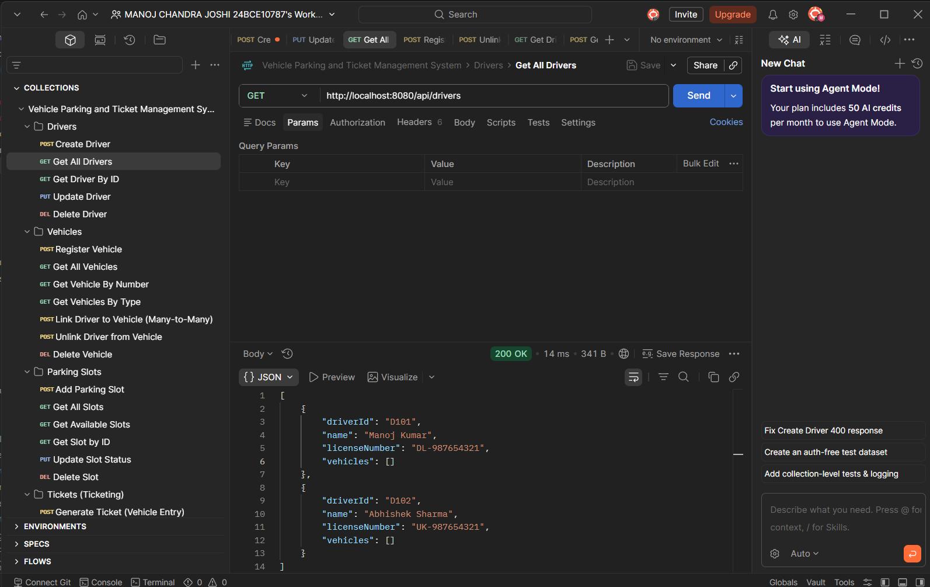
Postman screenshot for DRIVER Method - GET
------------------------------------------------------------------------------------------------------------------------
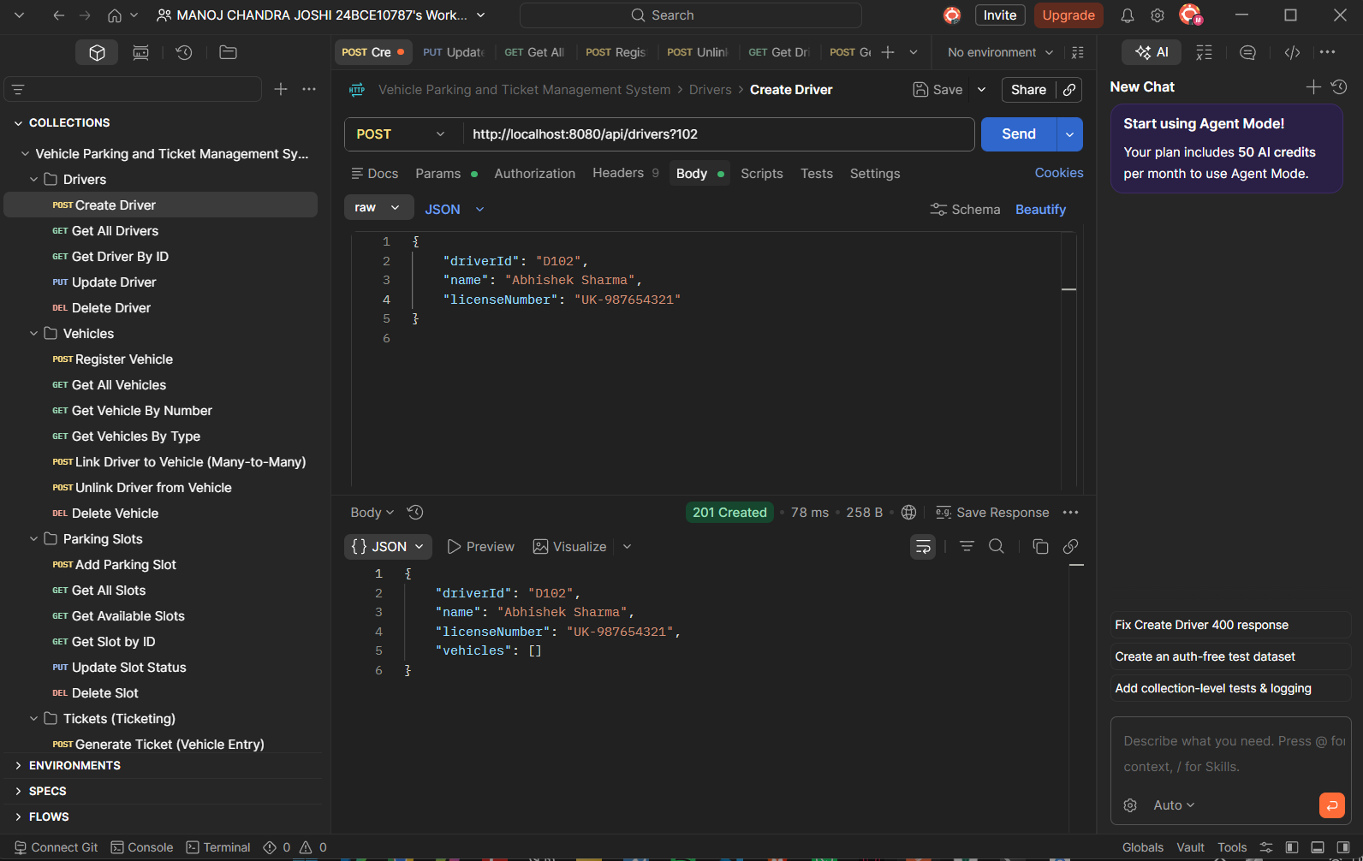
Postman screenshot for DRIVER Method POST
--------------------------------------------------------------------------------------------------------------------------
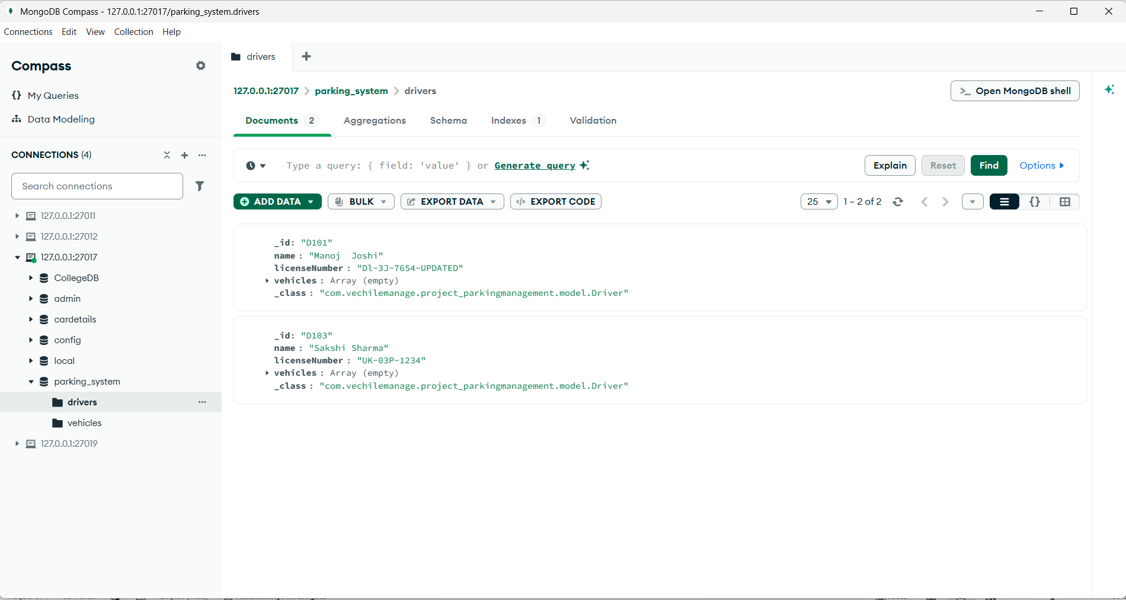
Updated MongoDB Database

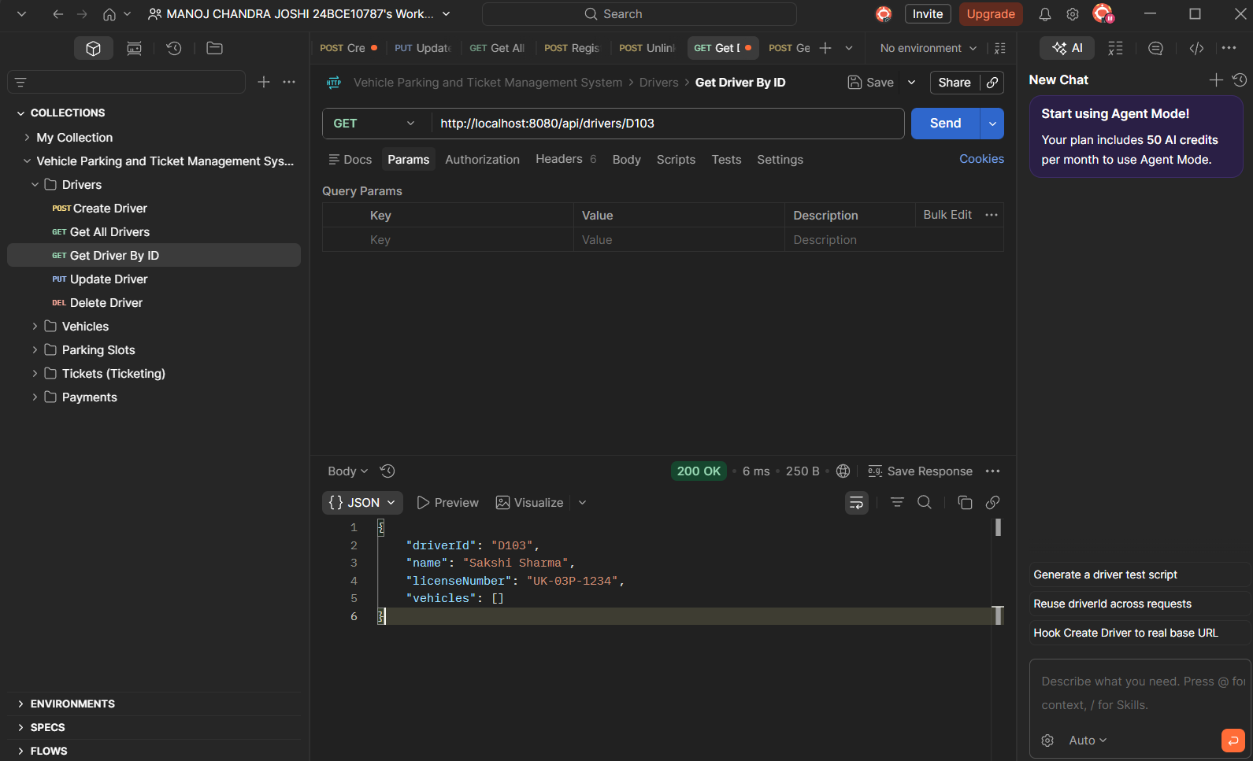
GET Driver by id FIND OPERATION

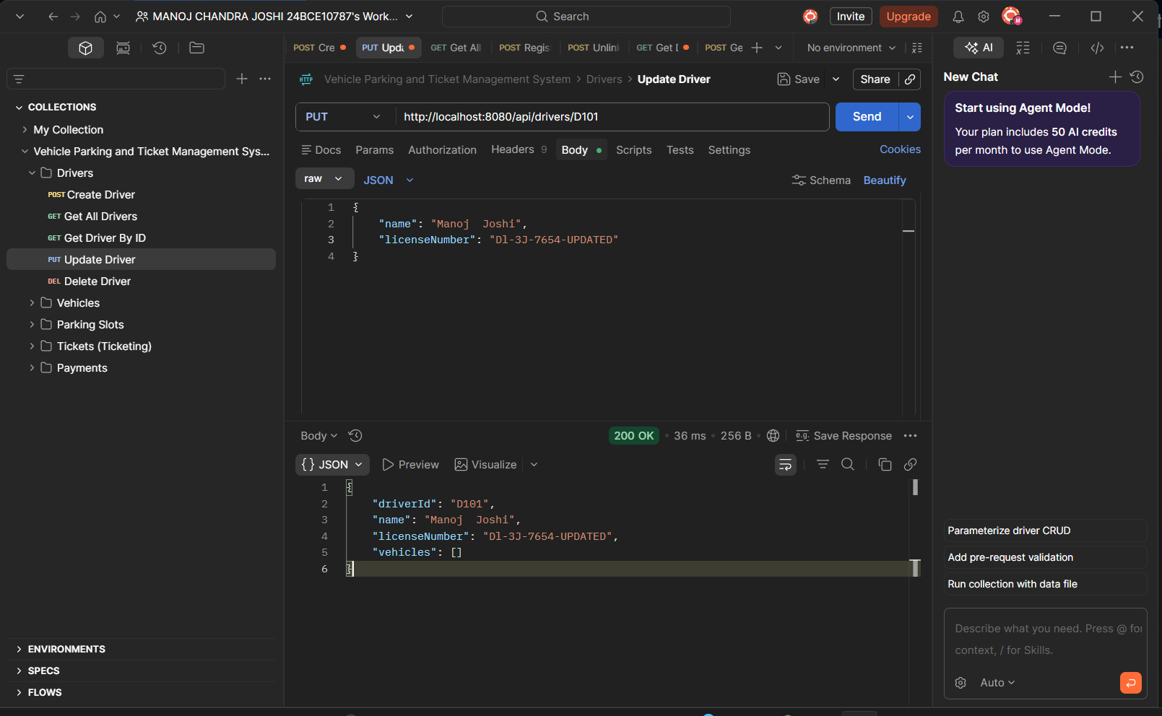
PUT Method used to edit Driver name and licenseNumber for D101
--------------------------------------------------------------------------------------------------------------------------
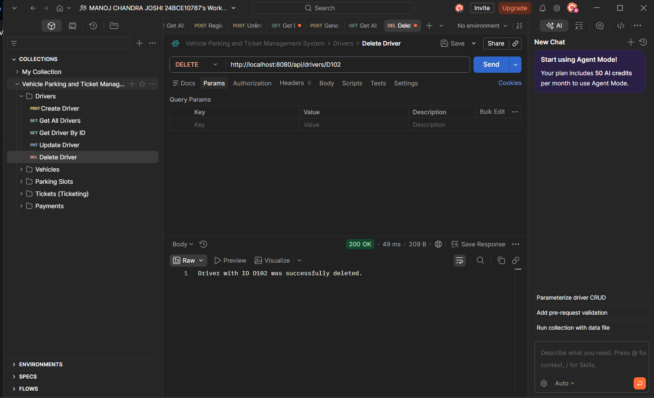
DELETE Method used to delete D102

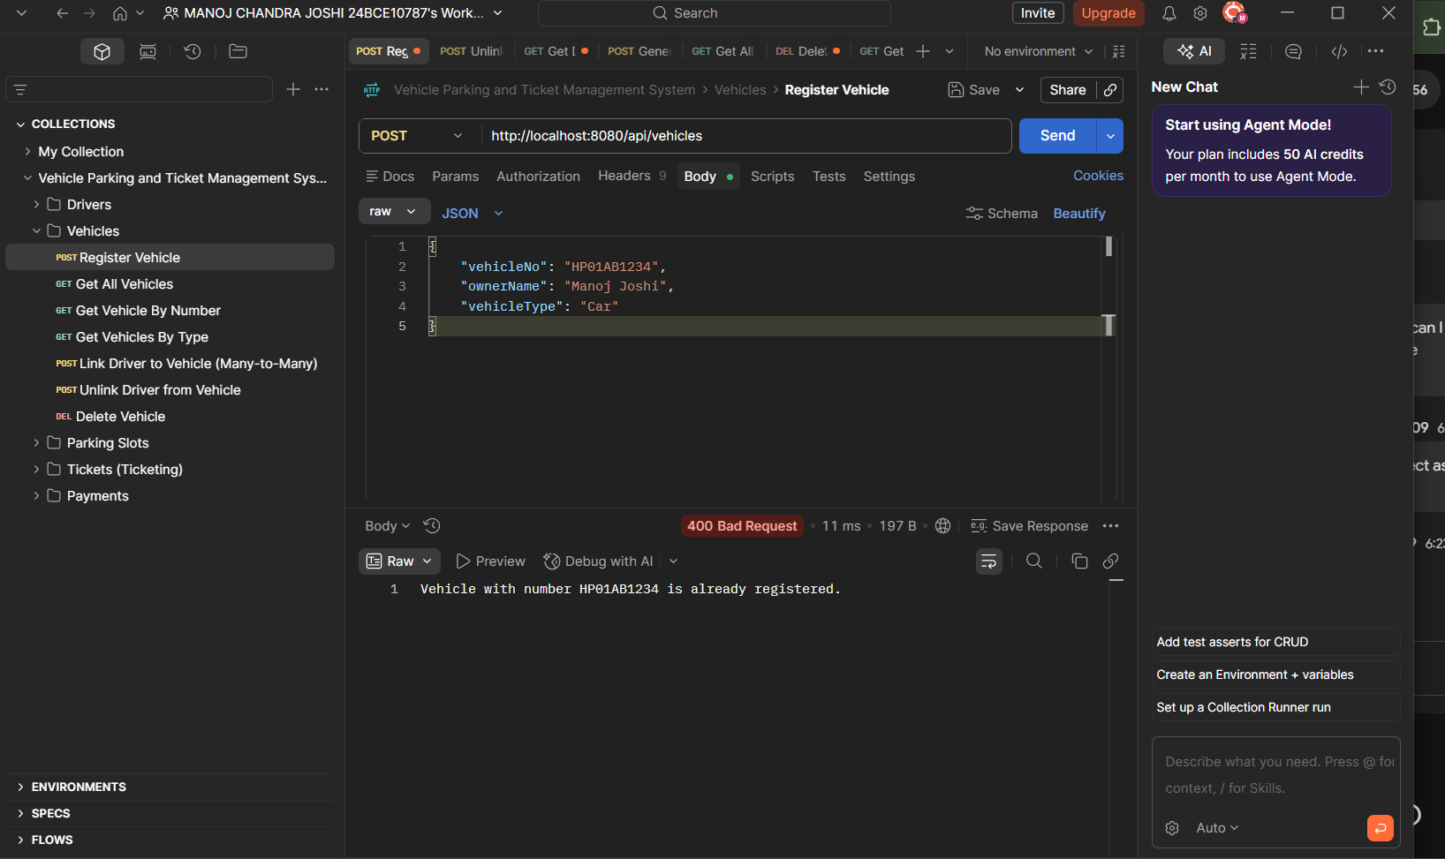
VECHILE SECTION ---REGISTERING VECHILE 400 BADREQUEST AS VECHILENO IS ALREADY REGISTERED

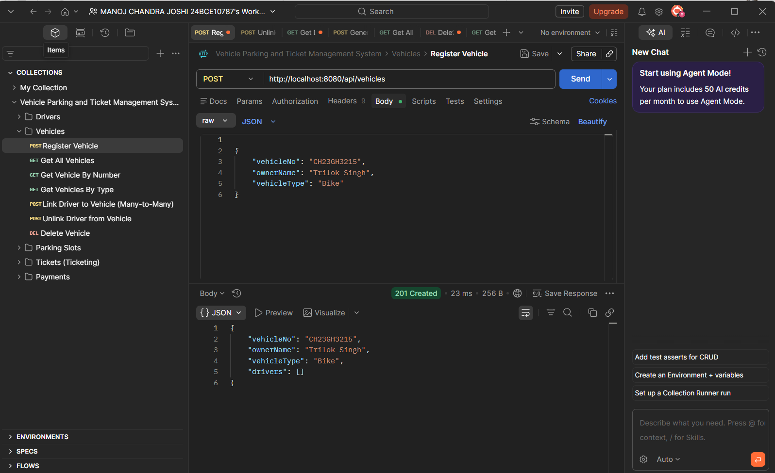
Register VehicleBIKE
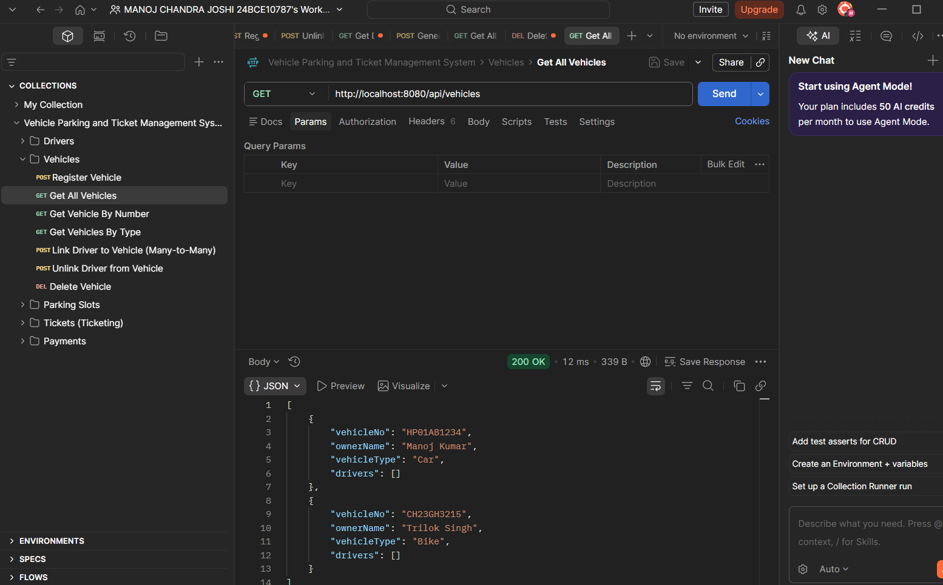
Get data of vehiclespost

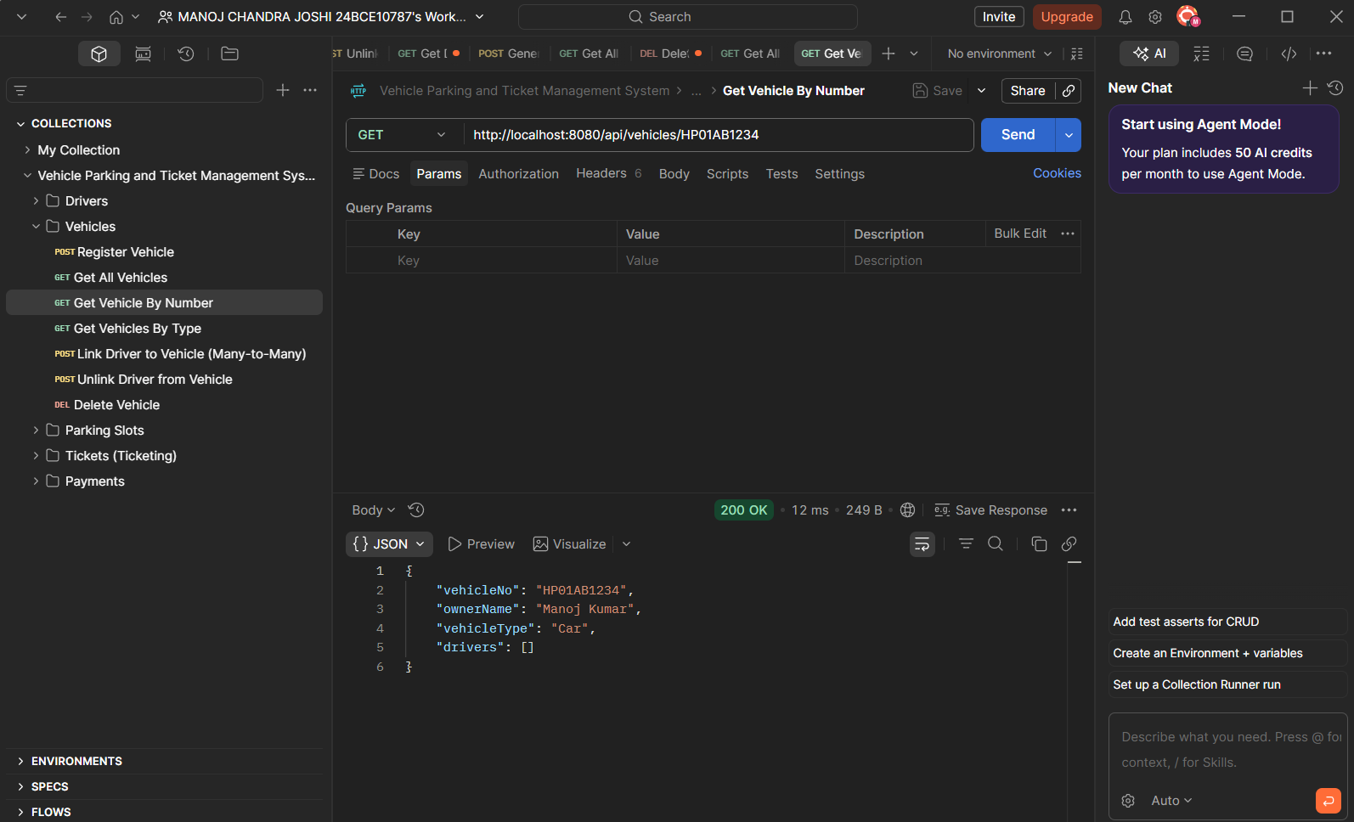
GET VEHICLE BY NUMBER
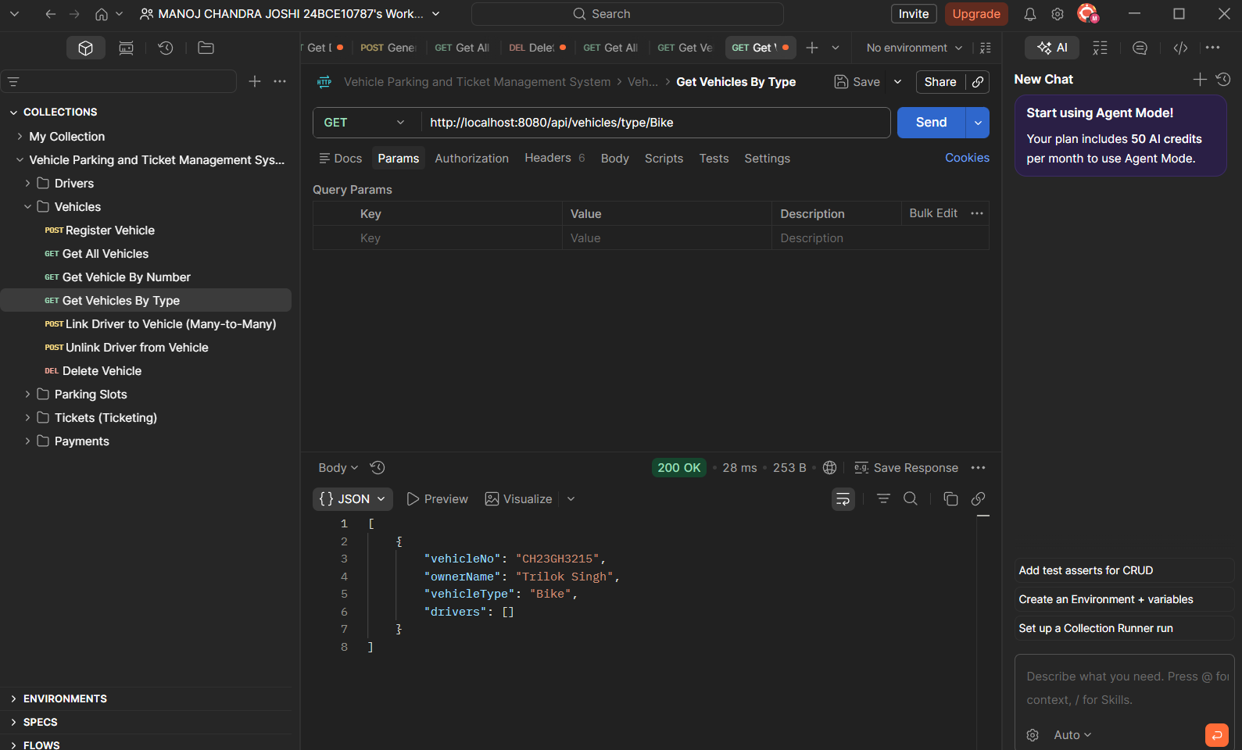
Get vehicle by TYPE
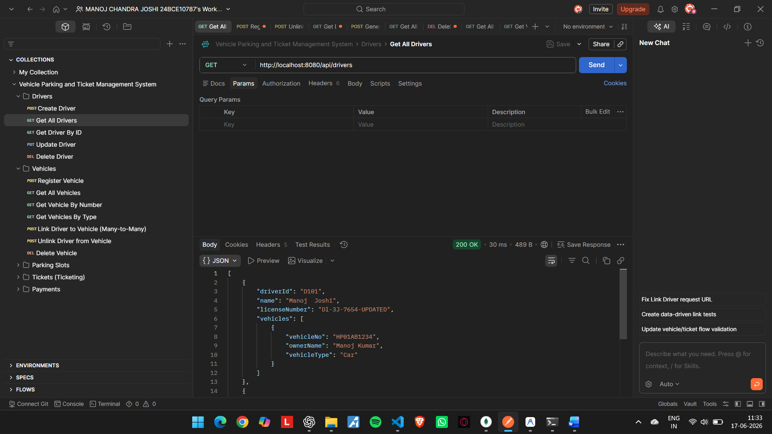
Linking Relationship many to many
--------------------------------------------------------------------------------------------------------------------------

--------------------------------------------------------------------------------------------------------------------------
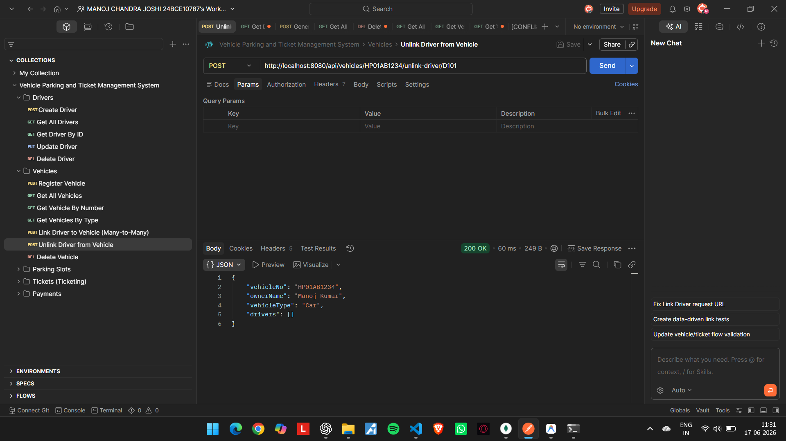
Unlinking the driver D101
--------------------------------------------------------------------------------------------------------------------------
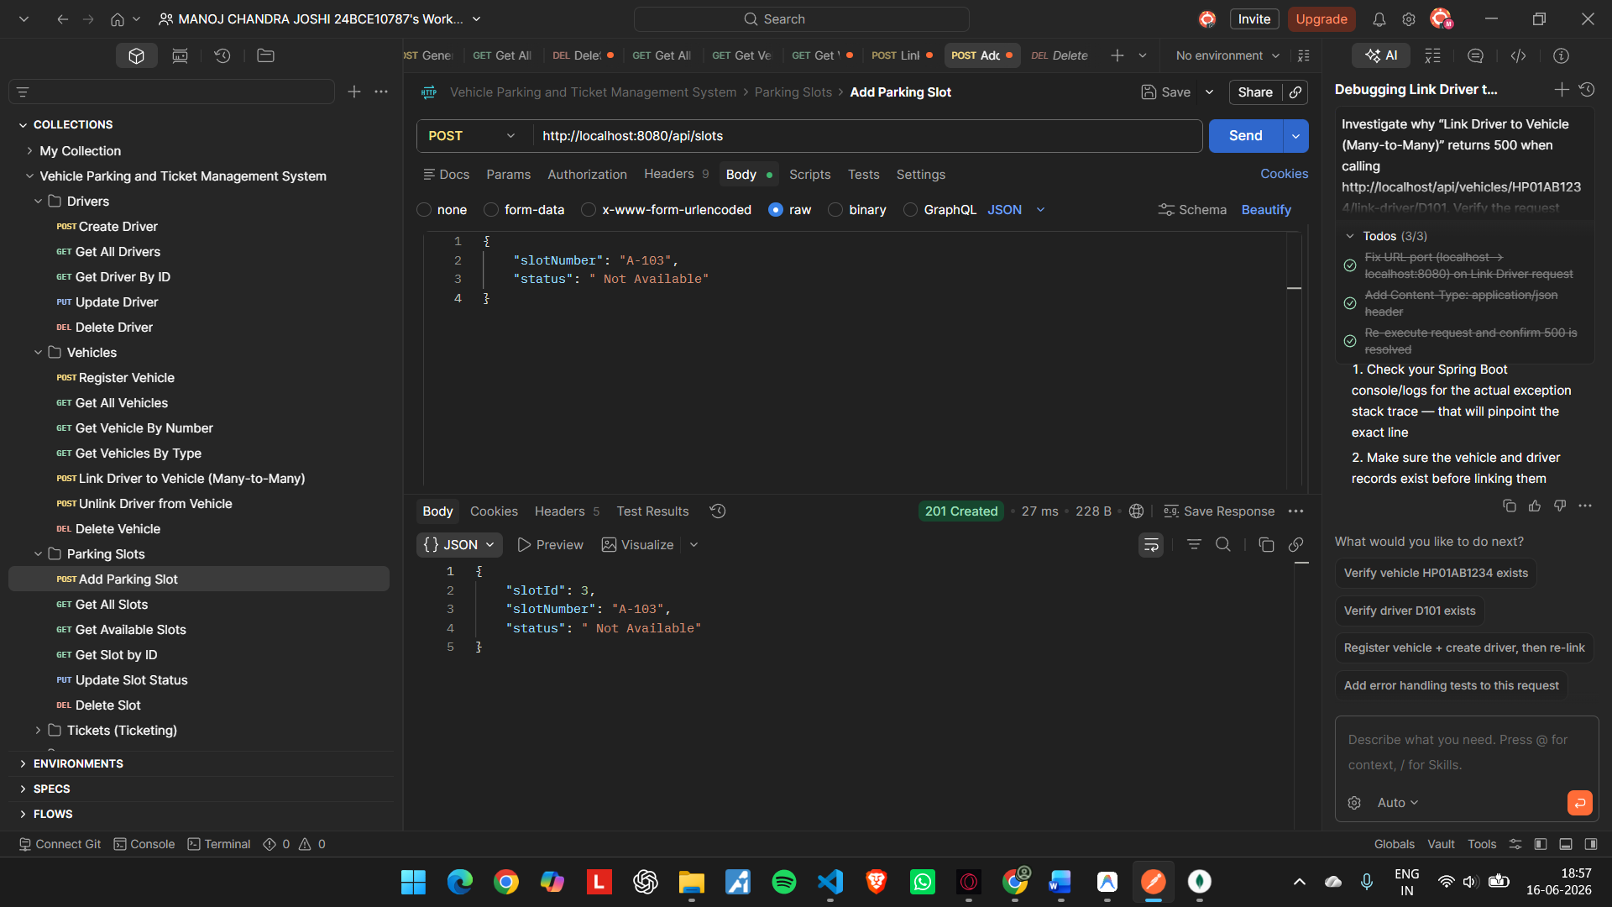
Adding parking slots post method
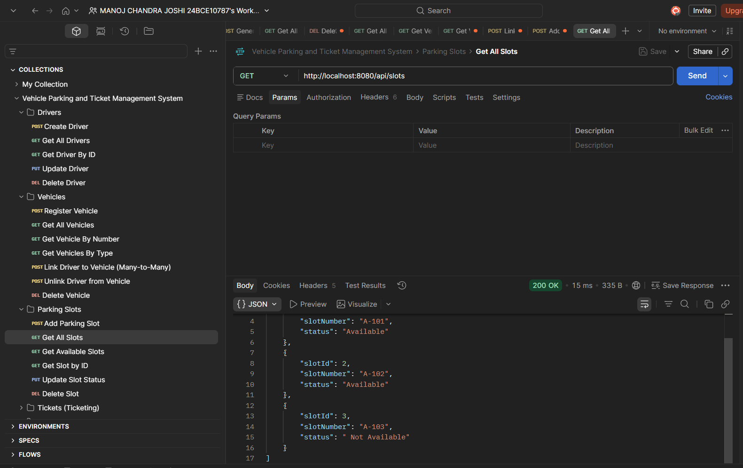

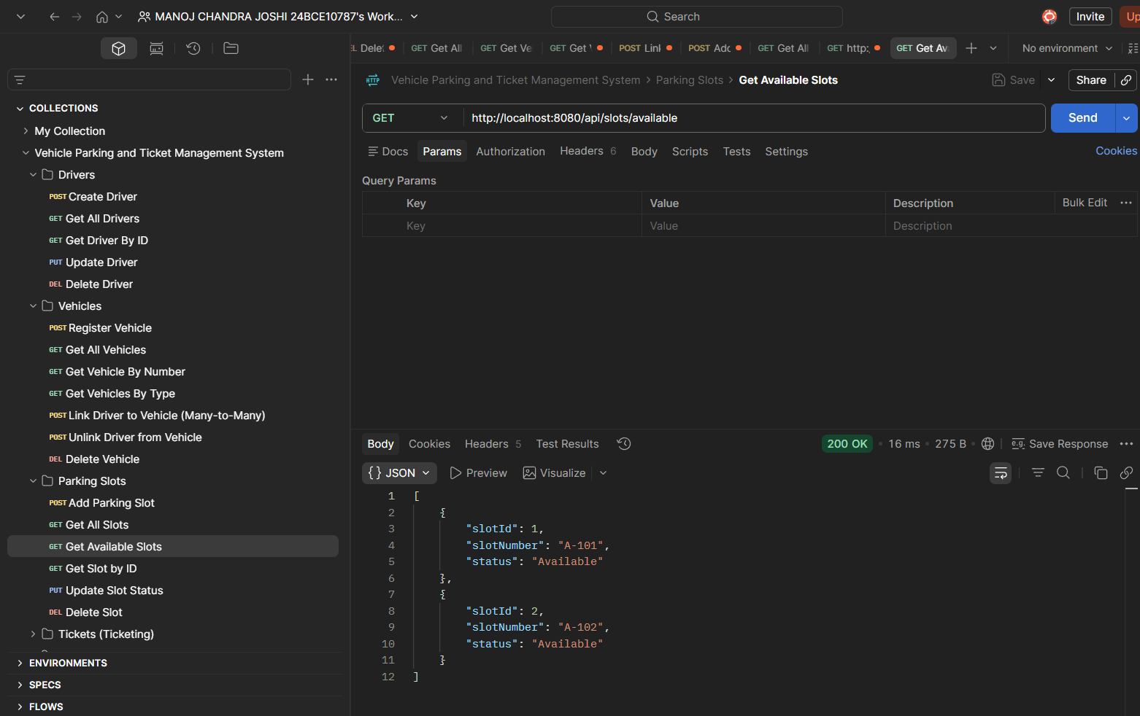
GETTING AVAILABLE SLOTS
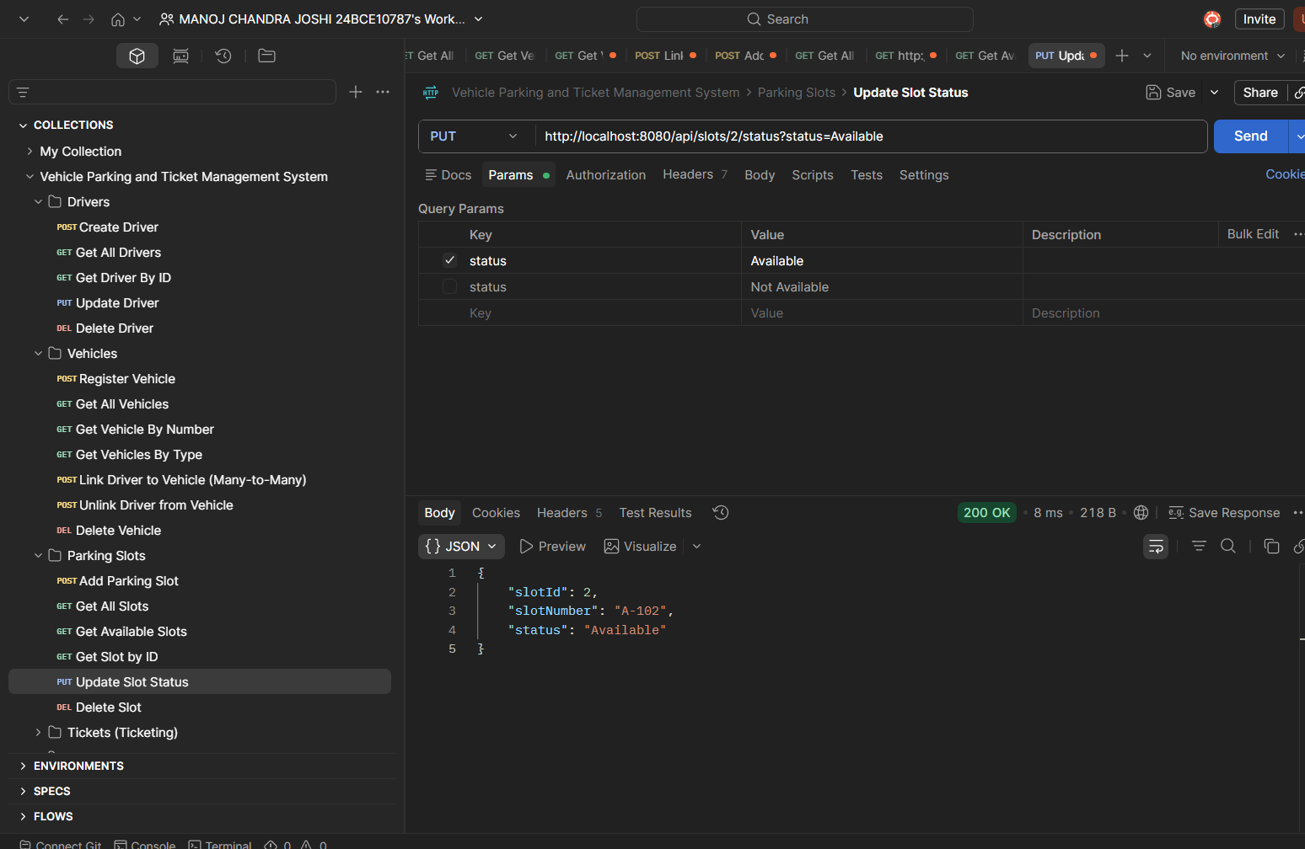

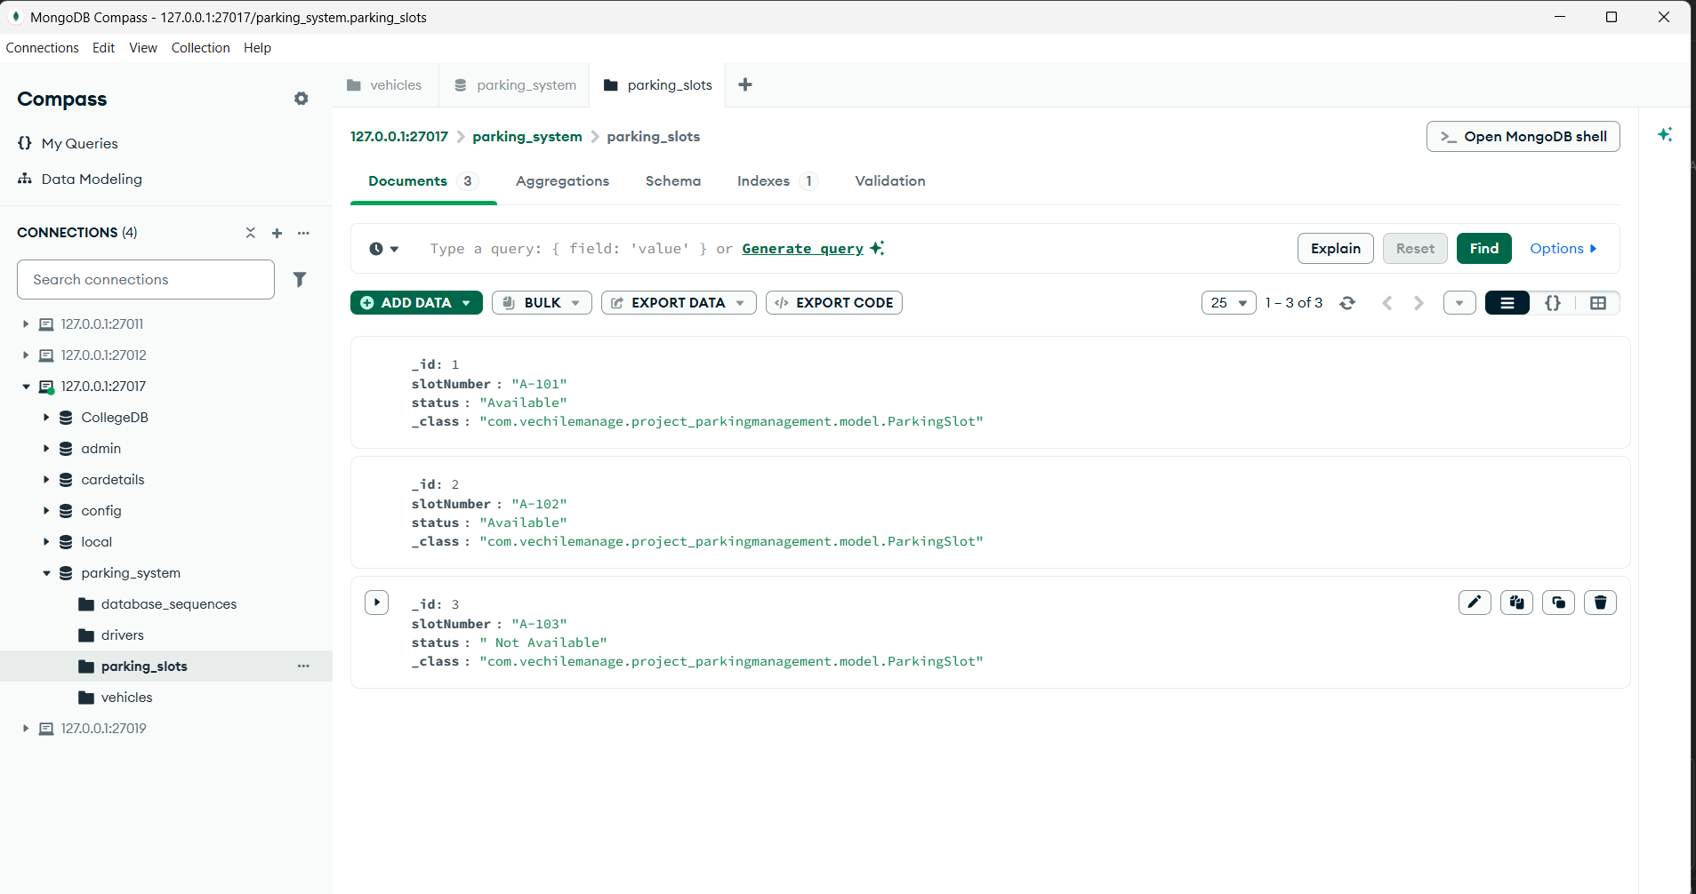
MongoDB database from Compass for parking
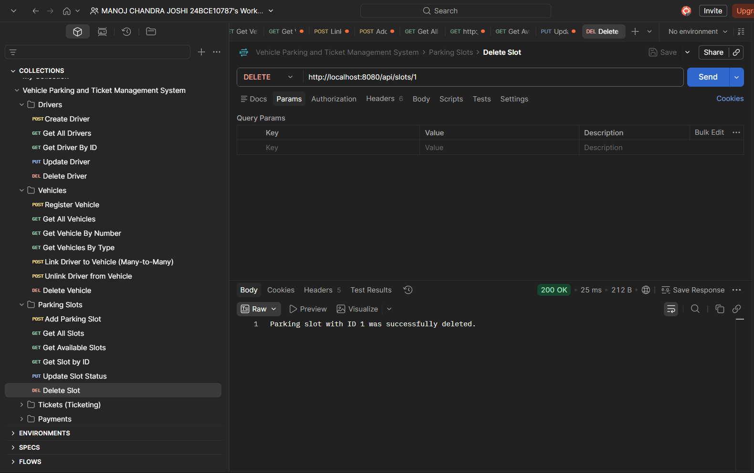
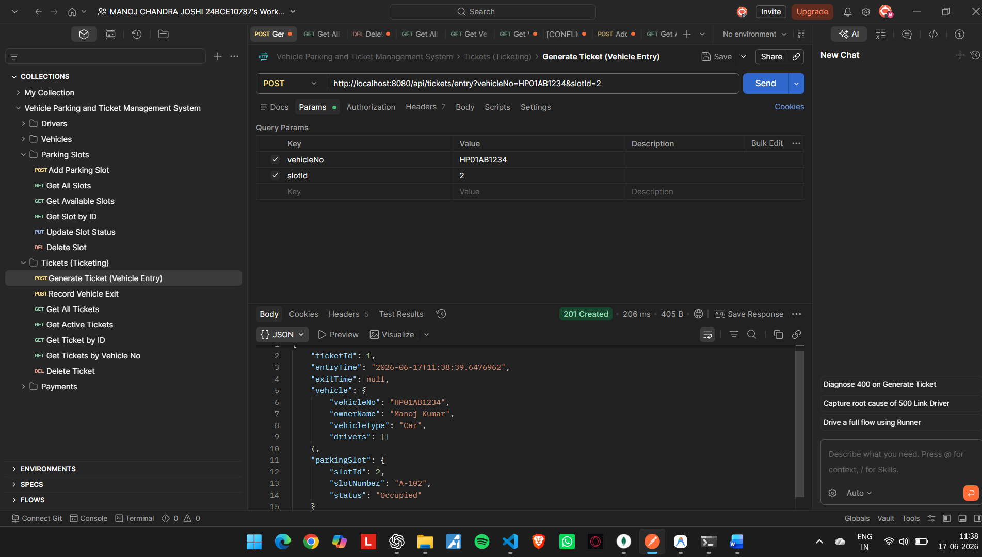
Ticket generation on each entry of the vehicle

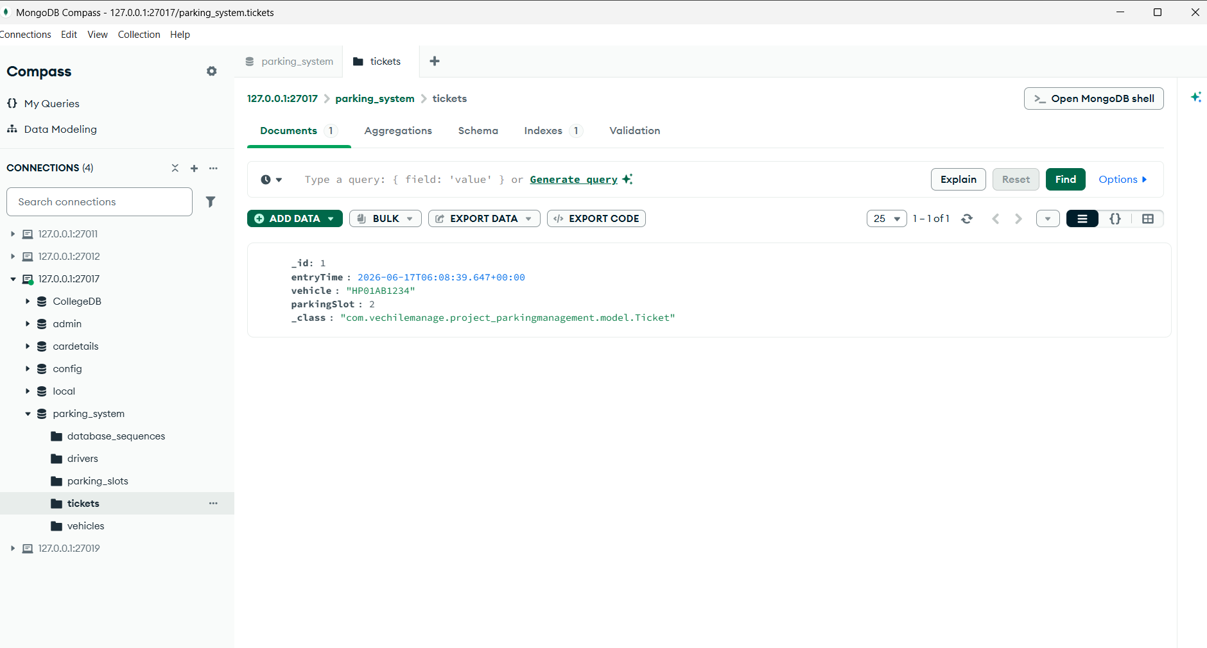
MongoDB database for TICKETS
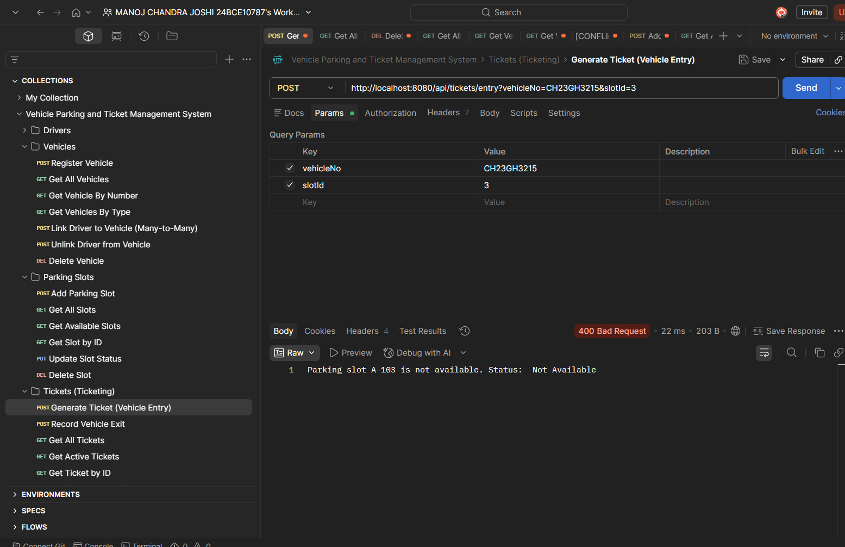
As Parking slot A-103 is not available its showing 400 Bad request

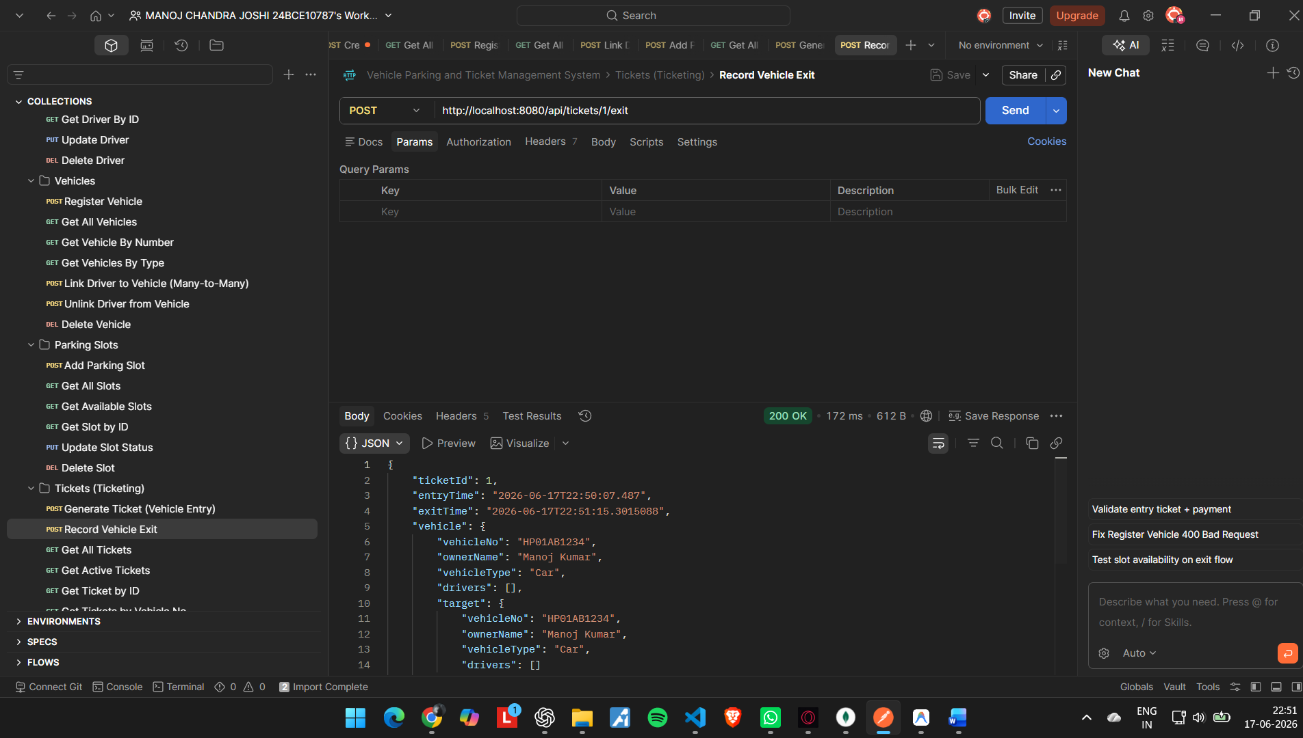
RECORD VEHICLE EXIT POST METHOD

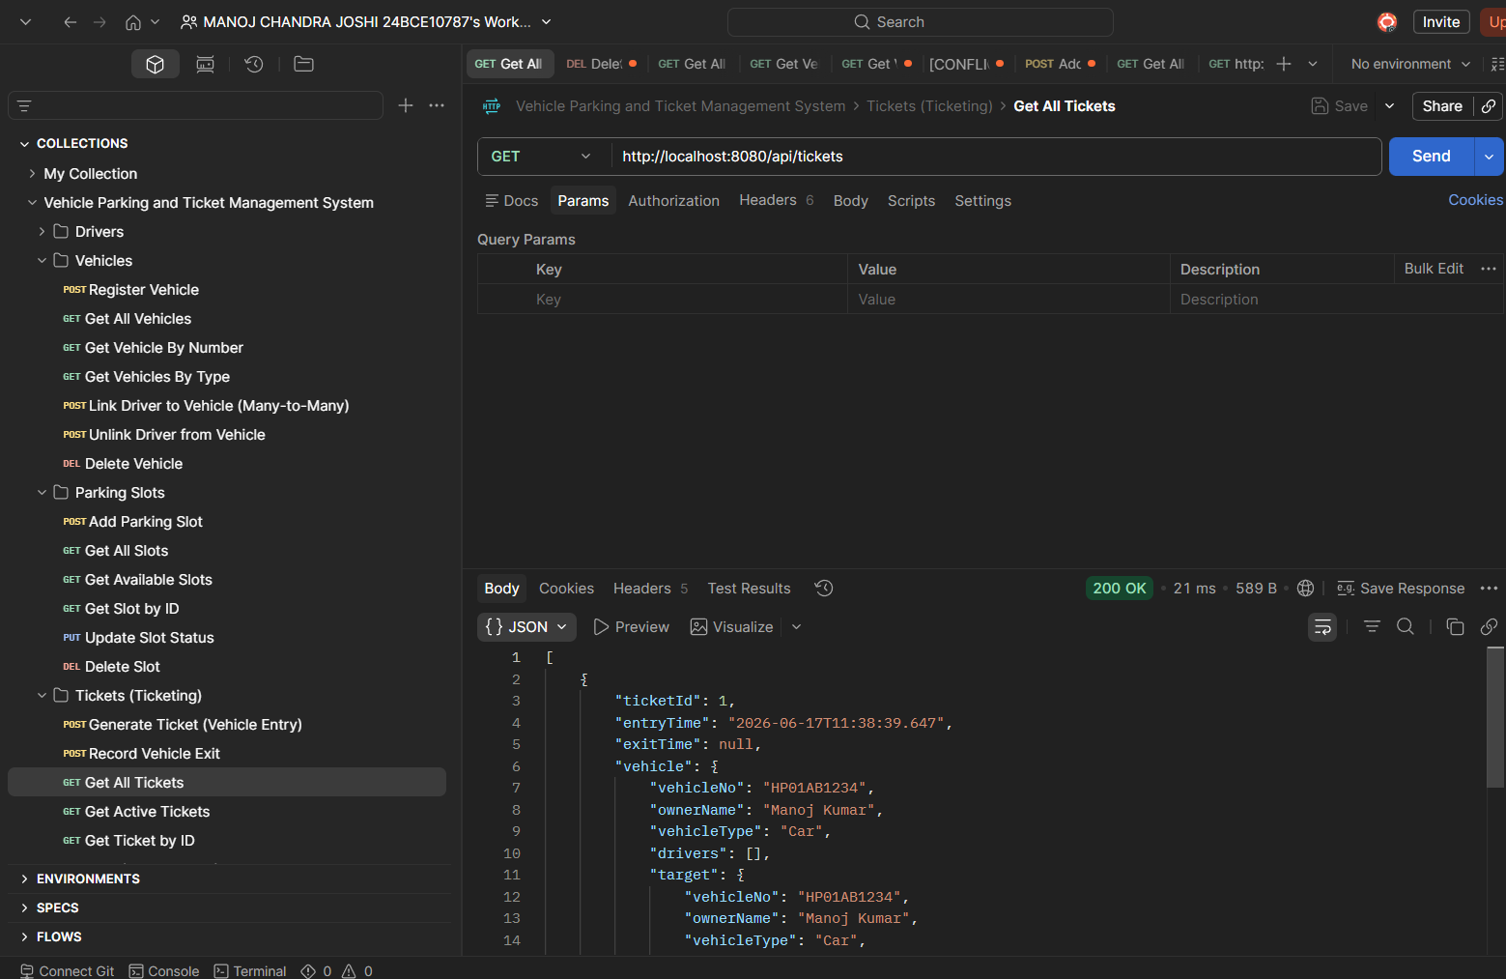
Get all ticket info
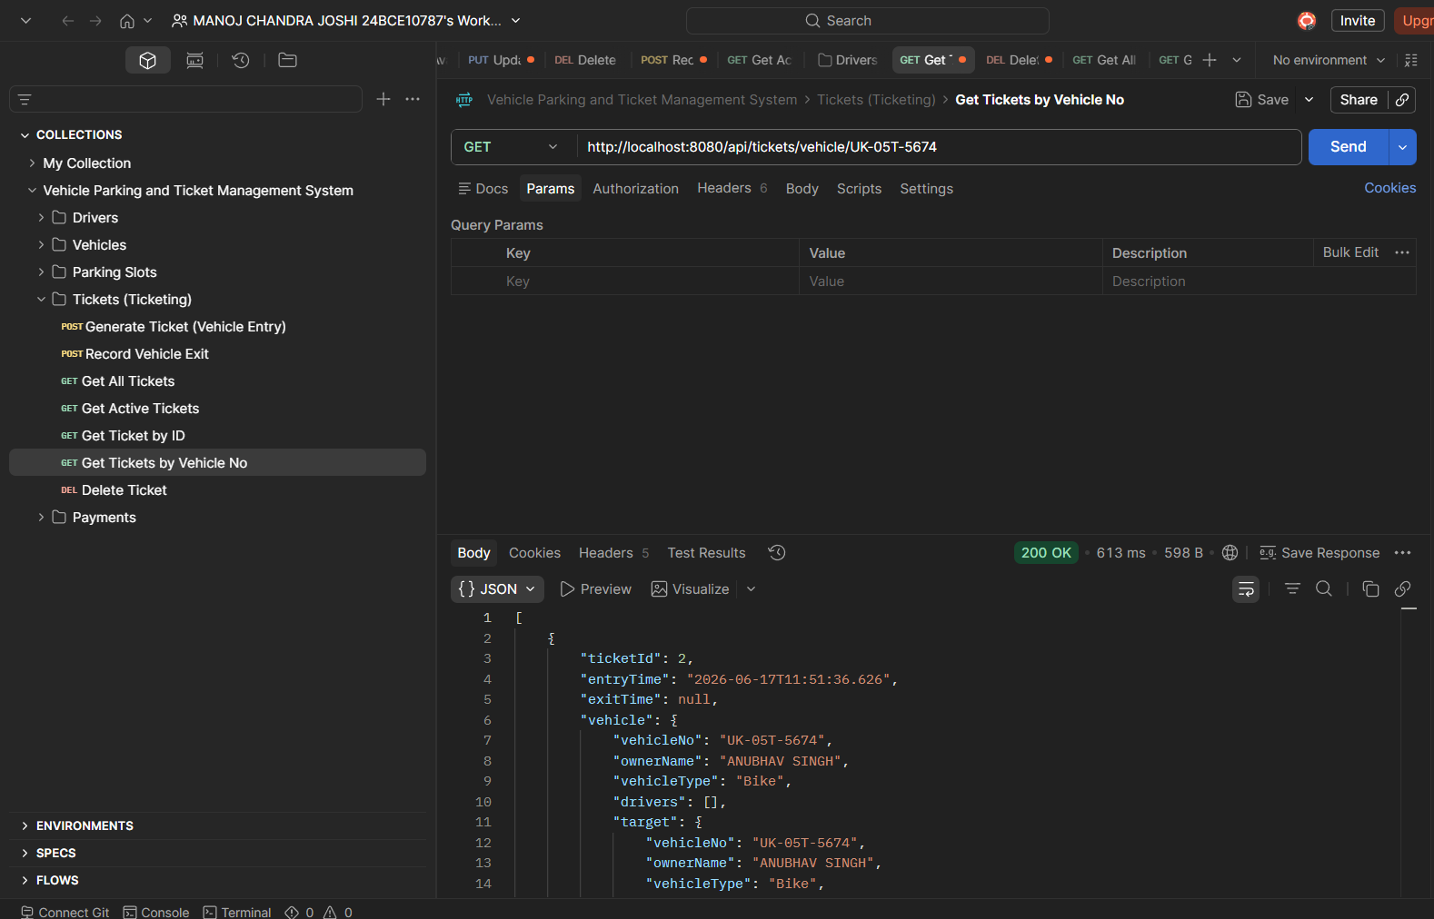
GET ticket by id

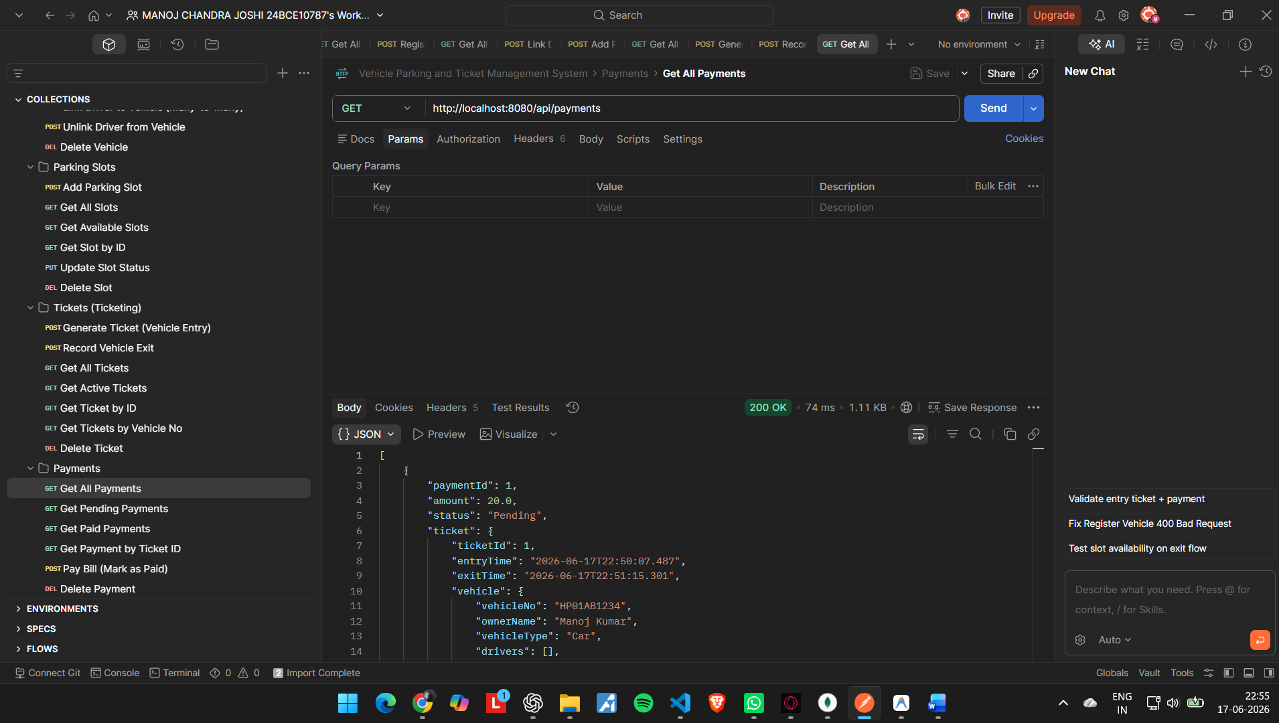
PAYMENT GETTING ALL THE PAYEMENT

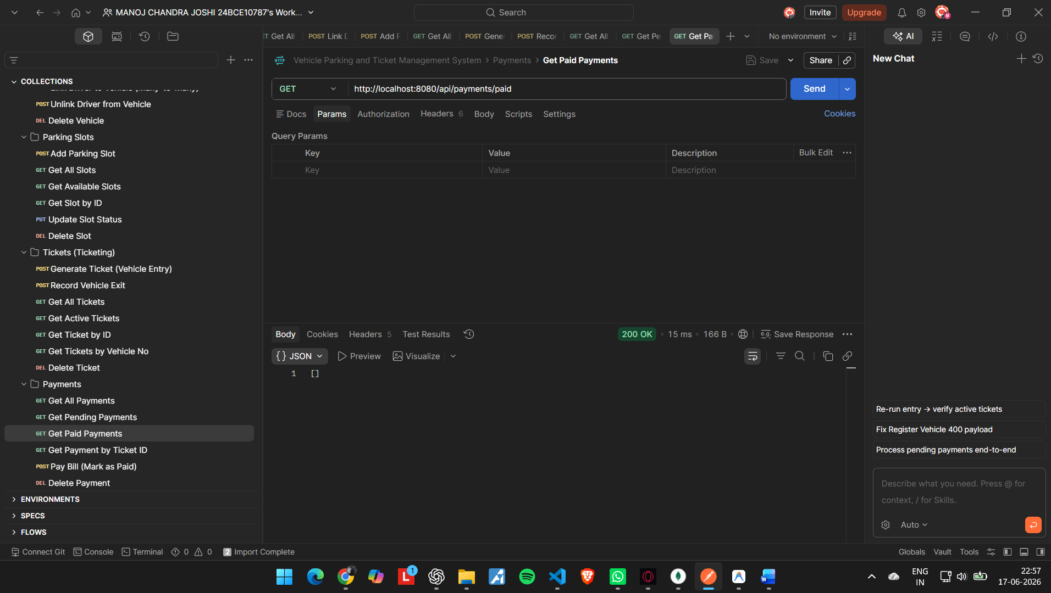
Its showing [ ] because there no data which currently paid the payments
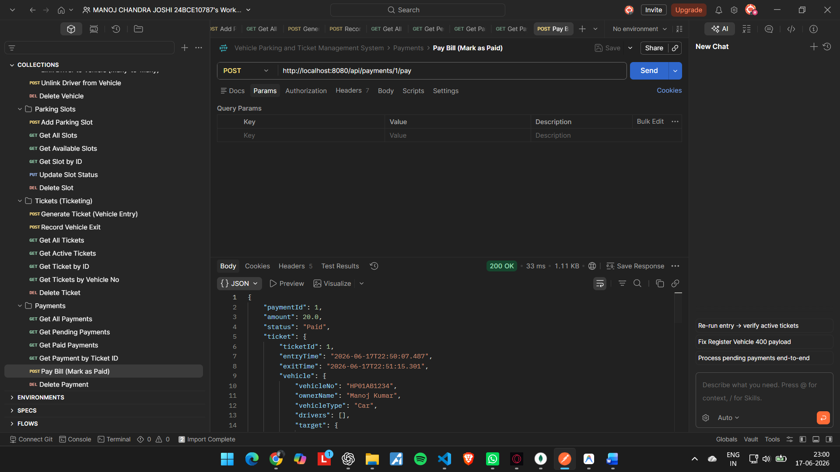
Paid the payment by id:1

